CALL FOR SUBMISSIONS:
Community engagement for inclusive rural transformation and gender equality
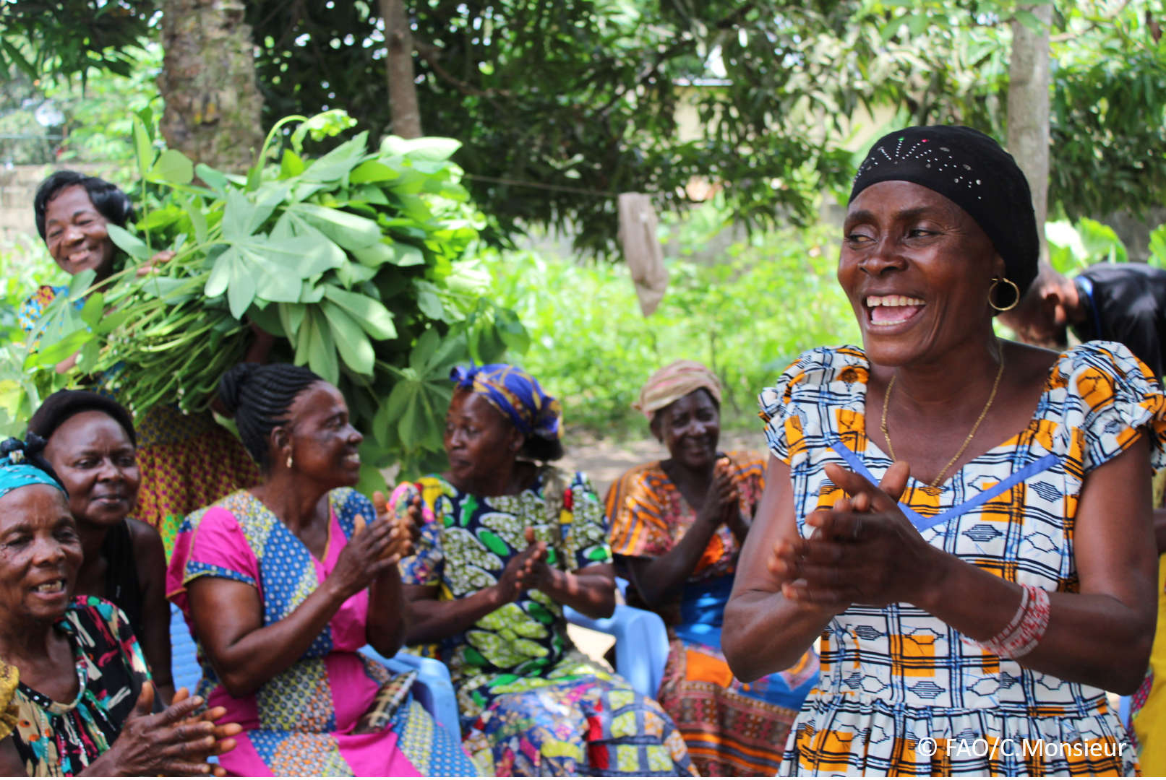
The objective of this call for submissions is to collect good practices, experiences, and lessons learnt on the use of community engagement for inclusive rural transformation and gender equality. The initiative, organized by the Rural Transformation and Gender Equality Division (ESP), seeks to gather insights from a diverse range of contributors, both within FAO and from external stakeholders. Its goal is to share knowledge, foster learning, and guide the scaling up of community engagement and community-led collective action to leave no one behind. The call builds on FAO's past efforts in this area, such as the Community Engagement Days series of webinars.
The call for submissions is open until 27 November 2024.

How to take part in this call for submissions:
To take part in this Call for submissions, please register to the FSN Forum, if you are not yet a member, or “sign in” to your account. Please review the topic note to understand the criteria we are considering for this call. If you wish to learn more about community engagement, you may refer to the background document. Once you have completed this submission template, upload it in the box “Post your contribution” on the call webpage, or, alternatively, send it to fsn-moderator@fao.org.
Please keep the length of submissions limited to 1,500 words and feel also free to attach relevant supporting materials.

Template for submissions

Contact person | Name: NABUGUZI SARAH  Organization/Unit: KATOSI WOMEN DEVELOPMENT TRUST  Country:UGANDA  Email address: nbgzviola@gmail.com
Name/title of the good practice | Women Empowerment
Where is the good practice taking place? (Multiple selection allowed) | ☐ Europe and Central Asia  ☐ Latin America and the Caribbean  ☒ North Africa and Near East  ☐ Sub-Saharan Africa  ☐ Asia and the Pacific  ☐ North America  ☐ Global
Affiliation | ☐ Farmer and producer organizations  ☐ Trade Union  ☐ Informal community-based, farmer-based or self-help group  ☐ Research and academia  ☐ Government  ☐ Local/traditional authorities  ☐ Private Sector  ☒ Civil Society Organization  ☐ Intergovernmental Organization (e.g. UN system, World Bank)  ☐ Resource Partner/Donor  ☐ Other (please specify)
In which sector(s) and context (s) have you used this community engagement good practice? (Multiple selections allowed) | ☒ Education  ☐ Health and Sanitation  ☐ Food production in agrifood systems (please also tick the sub-categories)  ☐ Crop cultivation  ☒ Fisheries and aquaculture production  ☐ Livestock  ☐ Forestry  ☐ Agroforestry  ☐ Horticulture  ☐ Apiculture (beekeeping)  ☐ Agroecology and sustainable farming practices  ☐ Soil and water management  ☐ Other: ____________  ☐ Post-production in agrifood systems (please also tick the sub-categories)  ☐ Processing and value addition  ☐ Marketing and retailing  ☐ Transporting  ☐ Food loss and waste  ☐ Packaging  ☐ Storage  ☐ Distribution  ☐ Other _________  ☒ Gender Equality  ☐ Climate Action  ☐ Citizenship and Governance  ☐ Social Protection  ☐ Humanitarian and protracted crisis  ☒ Conflict resolution, peace and resilience  ☐ Digital innovation  ☐ Other sector (please specify) _________
Who are the financial partners supporting this good practice, if applicable? | Giz,Achenova
- In a few sentences, summarize your community engagement good practice.
We have held Human Rights Trainings on the gender equality, Originally women were looked as house wives and owning property was mainly for Men ,After trainings women were educated about their different rights ,to put this to good use some women that were not legally married got married to secure their security on the husbands property.
- What problem(s) or challenge(s) does your good practice aim to address through community engagement? They aim to address woman’s rights.
- Describe your good practice in more detail. Include the main guiding principles, the desired changes or outcomes you aim to achieve (Theory of Change), and the key phases of implementation.
We have had Capacity Building trainings to educated women, Youth and the community about equal rights for resources, especially the Lake, we work with vulnerable fishing communities of Mukono,Kalangara and Buvuma .
What guided us to do gender equality is we had a component of micro-credit scheme and since we work with women, they complained to us that the banks were denying them access to credit since they didn’t have collateral security and that is property and land, all the house property were for their Husbands , we realized we had to do awareness creation for our women and youth for them to know their rights in marriage and and to break family customs of a women can own property ,
OUTCOMES
We have trained women on the SSF Guidelines emphasing the issue of equality for all when it comes to resources.
We give small loans to our women for them to have a purchasing power like the men when it comes to property and purchasing fish on the lake.
Created a linkage between the community and the services providers like government and for them to demand for accountability and equal access.
- Who are the key actors and stakeholders involved in the design and implementation of the good practice, and what are their respective roles? Consider local partners, government, local authorities, community radios, civil society, research, the private sector, etc.
The main actors were the women councillors, Police, Local Leaders ,Lawyers , community Radios , Gender and Labour office, Community Trainers
- How does your intervention ensure inclusivity and equal and meaningful participation within the community?
Describe how your intervention includes and engages different groups within the community. Consider aspects like gender, age, ethnicity, disability status, livelihoods, and other specific conditions (e.g., people living in prolonged crisis, migrants, refugees). Explain how your intervention engages diverse segments of the rural community. Highlight the specific actions or strategies you use to reach these groups. If applicable, mention if your intervention uses specific approaches such as gender-responsive, gender-transformative, intersectionality, or other methods to ensure inclusivity and gender equality.
- We carry out community Dialogues for everyone to give their opinion, in case of bylaws, services. This usually brings local leaders in all departments where we work.
- The facilities we construct are user friendly for all even the PWDS
- We give capacities like trainings, facilitation for women to advocate for issues affecting their communities on the different platforms, even national wide .
- We provide information for lawyers incase someone’s rights are violated.
- We encourage dialogue with key leaders in the gender

- By using community engagement, what results and impacts have your good practice achieved?
- They Formed community self-help groups to handle and train other marginalized groups like the PWDs again equal rights.
- We have formed women groups that advocate at the subcounty for social inclusiveness, advocate, equal rights on the lake while Fishing, They work together as a group to defend their fellow money incase their rights are violated , They also do community parading to make sure parents send their kids to school instead of child labour.
Please provide specific examples and evidence demonstrating the effectiveness of your intervention, focusing on both qualitative and quantitative outcomes related to livelihoods and well-being improvements.
- Among these results, has the good practice led to improvements in terms of gender equality, women’s empowerment, and/or social inclusion?
- Women have taken up leadership roles both at local level and subcounty level.
- When we are constructing facilities like toilets, we put in mind the marginalized people to equally use the facilities with easy.
- We have formed advocacy groups
- We have given women boats to fish on the lake just like the men
Describe the behavioral changes in terms of gender that the good practice promotes, emphasizing agency, leadership, and participation in local governance. Include efforts to challenge discriminatory norms and unequal power dynamics. Highlight also how the intervention has supported the well-being (including psychological resilience) of marginalized groups and enhanced their inclusion and participation in decision-making processes.
- What key challenges did you encounter while implementing the community engagement activities, and how did you address them?
The unfair culture norms in the societies where we conducted the gender equality trainings, some Men didn’t want their women to attend such trainings, this was also due to ignorance to some people,
We addressed it by calling cultural leaders in the same meetings, so that even those that were ignorant can learn and unlearn.
The civic space in which we operated has been limited by the government, they censor what we say and where especially when it comes to human rights.
Include any resistance from communities, pushback, or issues related to unequal power dynamics, if applicable.
- What are the key lesson learned from your community engagement good practice?
In the communities were we work the youth have been left out in most of the engagements yet we have rising number high early marriages, and high domestic violence leading to high level of human rights violations ,
Access to resources for them is minimal, these type of awareness campaigns would be good if they are given capacity to lead
- Has this practice been replicated in the same context or in different contexts?
To a small context yes but we were limited by funds, this would be good to do in all the fishing communities of Uganda because the situation there is alarming given the resources /funding
- What are the required conditions to replicate and adapt the practice in another context/geographical area?
- How sustainable are the results achieved by this good practice?
We selected local women group communities, first to train other community members that were not present about gender based violence and equlity for all especially in families ,but also the policy and the local leaders that were present in the meetings where urged to revive their roles and to work hand in hand with the committees that were selected .
Describe the key elements that need to be in place to make the initiative sustainable, including enabling environment (legal and policy frameworks and institutions), local ownership, accountability, etc.
- Based on the conversations FAO held during the Community Engagement days, a definition of community engagement for empowerment was proposed:

“Community engagement for empowerment and community-led collective action can be defined as an inclusive and participatory process that enables community members to become active agents of change in decisions affecting their lives, health, and environment. This process develops their capacity to achieve sustainable outcomes for improved rural livelihoods. Embracing a rights-based approach, it prioritizes the agency and participation of all community members, regardless of gender identity, sexual orientation, age, ethnicity, caste, socioeconomic status, political affiliation, migration status, or ability/disability. Indeed, inclusive approaches recognize the complexities of overlapping marginalization and discrimination that can exclude different community members from decision-making processes and implement strategies to foster their participation, agency and empowerment.”

We invite you to contribute to this definition. What would you add or change? Please share your thoughts, suggestions, and any additional elements you believe are crucial for a comprehensive understanding of community engagement approaches aimed at community-led collective action for inclusive rural transformation, people’s empowerment and gender equality.
This is a well thought of definition which tackles all aspects of what needs to attain a community led approach
- Based on your experience, what gaps or areas for improvement still need to be addressed in the field of community engagement?
- Policy awareness in the rural communities is still very poor.
- Corruption among government officials hinders Justice.
- Inadequate information IEC materials and platforms for People to air out their views.
- Lack of funding to create awareness on Gender Equality
- What do you think is FAO's role in the field of community engagement? How can FAO support and enhance interventions like yours, if applicable? Consider aspects such as policy advocacy, capacity development, funding, technical assistance, knowledge production and sharing, and fostering partnerships.
- Fao can help in designing IEC MATERIALS for creating awareness,
- Engage government in Talk shows in high level meeting to see to it that their policies are put in place.
- Funding for capacity Building trainings to create more awareness on women’s Rights and to facility bring services of lawyers.
- Funding for radio/Tv talk shows to create Awareness.
- Funding to document best practices for the other community members to learn from.
- Advocate for policy awareness through community Drives.

Link(s) to specific references about your good practice (e.g. reports, communication products, videos, articles) | Please include attachment(s) or add here link(s) to documents/videos/podcasts/other with specific references.  Katosiwomen@katosi .org  For more information and reports

The call for submissions is directly aligned with the thematic components of collective action within FAO's Programme Priority Areas (PPAs), specifically Better Life 1 (Gender Equality and Rural Women’s Empowerment), Better Life 2 (Inclusive Rural Transformation) and Better Life 3 (Agriculture and Food Emergencies).

